**Sales Data Analysis Report**

**Name: Pavan Kalyan Divve**

**Introduction**

This analysis focuses on sales data, examining key variables such as 'month,' 'customer_reviews,' 'promotion_level,' and 'sales.' The objective is to gain insights into the patterns, relationships, and predictive capabilities of these variables.

**Summary Statistics**

The summary statistics offer a snapshot of the central tendency and variability of the dataset:

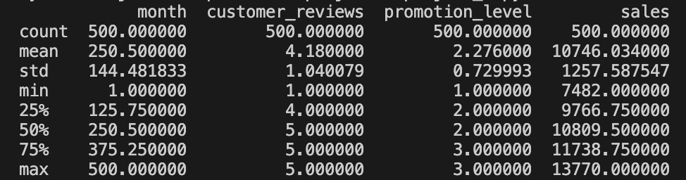

**Histograms of Numerical Variables**

Histograms provide a visual representation of the distribution of numerical variables. Refer to Figures 1-4 below:

Figure 1: Histogram of Month

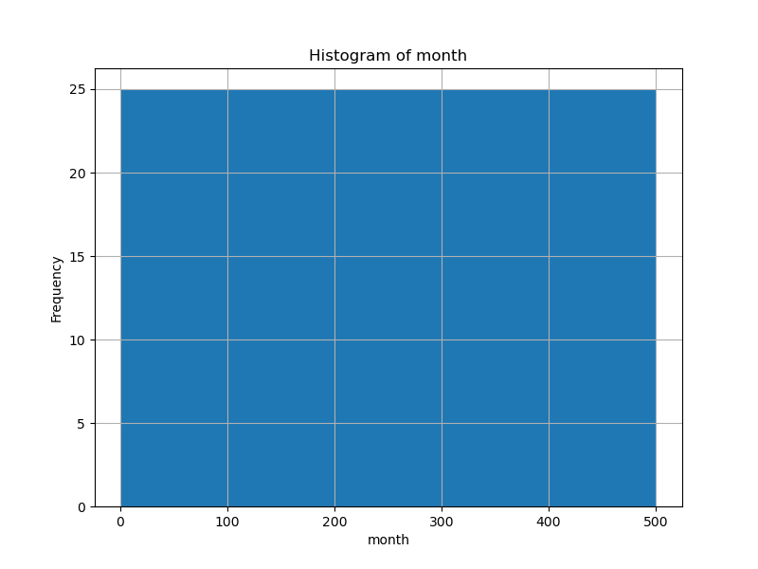

Figure 2: Histogram of Customer Reviews

Figure 3: Histogram of Promotion Level

Figure 4: Histogram of Sales

**Sales vs. Month**

Scatter plot illustrating the relationship between 'Sales' and 'Month (numerical)':

Figure 5: Sales vs. Month

Linear regression was applied to understand the trend. The regression line is plotted in Figure 6:

Figure 6: Linear Regression - Sales vs. Month

**Predictive Analysis**

**Predicted Sales for December**

Using linear regression, the predicted sales for December are approximately $8983.71.

**Actual vs. Predicted Sales**

Scatter plot comparing actual sales against predicted sales for the test set:

Figure 7: Actual vs. Predicted Sales

**Conclusion**

In conclusion, the analysis provides a comprehensive overview of the sales data, highlighting key statistics, distributions, and relationships. The linear regression models allow for predictions, and the visualizations offer insights into the patterns within the dataset. These findings can be valuable for strategic decision-making, marketing planning, and sales forecasting.